Incident

in

SimMobility

Short Term Simulator



|  |  |
| --- | --- |
| Author: | Kakali Basak |
| Status: | Draft |
| Version: | 0.1 |
| Date: | 5th Sep 2013 |

# Table of Contents

Table of Contents 2

0 Document Control 3

0.1 Summary 3

0.2 Document History 3

0.3 References 3

0.4 Distribution 3

0.5 Quality Assurance 3

1 Introduction 4

2 Incident setup 5

3 incident response - driver 7

3.1 Local Impact 7

3.1.1 Drivers on the incident lane: 7

3.1.2 Drivers on the other lane: 7

3.1.3 Drivers on the opposite side of the incident link 8

3.2 Network level Impact 8

3.2.1 Impact on the infrastructure based information 8

3.2.2 Impact on the non-infrastructure based information 8

3.2.3 Information Details 9

4 incident response - control devices 10

4.1 Incident Region 10

4.1.1 Reference Point for normal road 10

4.1.2 Reference Point for roads within a tunnel 11

4.2 Lane Usage Signal 11

4.3 Variable Speed Limit Sign (VSLS) 12

4.4 Portal Closure 13

4.5 Variable Message Sign 14

5 Appendix 16

# Document Control

## Summary

This document describes the requirement of incident implementation in SimMobility short term simulator. SimMobility must provide the modelers the options to simulate different incident scenarios.

## Document History

|  |  |  |  |
| --- | --- | --- | --- |
| **Version** | **Date** | **Author** | **Changes since last version** |
| 0.1 | 9th Sep 2013 | Kakali Basak | First draft |
|  |  |  |  |
|  |  |  |  |
|  |  |  |  |

## References

## Distribution

## Quality Assurance

|  |  |  |  |  |
| --- | --- | --- | --- | --- |
| **Step** | **Description** | **Undertaken By** | **Date** | **Remarks** |
| 1 | Quality Review |  |  |  |
| 2 | Project Manager |  |  |  |
| 3 | Executive Review |  |  |  |

# Introduction

An incident is defined as an unexpected non-recurrent event that causes a capacity reduction of the road network or sudden increase of demand. Such events can be vehicle collision, vehicle break down, reconstruction of the traffic infrastructure or can be special events like a concert or football match.

This document describes requirement for incident simulation & response in microscopic level specifically to address those incidents, which will cause a capacity reduction. Incident simulation will include the configurable input parameters about the incident, driver’s access to the incident information, driver’s compliance towards the incident information and driver’s action towards the incident, which is simulation output.

# Incident setup

To simulate incident user must input certain parameters so that value of these parameters can be varied to simulate different incident scenarios.

* Visibility Distance – The distance from where drivers can see the incident.
* Incident Start Position (Segment ID) – Segment id where the incident took place
* Incident End Position - as a fraction of segment length from downstream end of the segment
* Severity Code **(**0=ignore 1=minor 2=major**)** - User will be able to configure different severity code and this information will be send to the drivers to capture driver’s action on different severity of the incident.

severity code indicates whether or not incident happen at a given lane. if severity code value is greater than or equal to 1.0, that means incident will happen at a given lane. Simulator will generate **situation code** when severity code is greater than or equal to 1.0. Simulator use situation code to determine whether or not corresponding action applied to a particular situation.

*In MITSim, situation code only has two possible values: COMPLETE_BLOCKAGE+ EVADOWNSTREAM or PARTIAL_BLOCKAGE+ EVAUPSTREAM. The first value of situation code means that incident cause fully blockage and emergency vehicle only can approach the incident from downstream; the second value of situation code means that incident cause partial blockage and emergency vehicle can approach the incident from upstream or downstream.*

* Capacity Factor - The capacity factor defines the capacity reduction caused by the incident. Capacity of a segment is the maximum number of vehicles allowed to enter to the segment during a period of time(e.g. 15 seconds). Vehicles will determine whether or not to move to the next segment based on the capacity of the next segment. The range of the capacity factor defined in the incident is from 0 to 1, which will revise and reduce the current capacity of incident lane by multiplying to the default capacity of this lane. After incident is cleared, the capacity value will gradually be restored to default value.

*Capacity factor will not be used in the micro level*

* Incident Start Time – Start of the incident. Time when it was detected.
* Incident Duration – It will include the following
  + Time required to detect incident
  + Time from incident report to on-scene response
  + Time required to clear

*Real data includes the duration after the detection? How to determine the time to detect the incident?*

* Speed Limit – Indicates maximum allowed speed value in the incident segment.  Each segment has a default speed limit, the driver can check this value from current segment or view on a VSLS (variable speed limit sign at intersection) ahead.

Speed limit for each lane can be specified in the input file but the VSLS will display the segment level speed limit.

* ID of the lanes affected by the incident
* Incident ID
* Compliance Weightage – Once the agents will be notified about the incident certain percentage of driver will ignore and continue their usual behavior unless they are forced to react to it. This variable will indicate how much percentage of drivers will actually comply to the information and react to it.
* Information accessibility – With the latest advancement of the technology, information is available to a large number of populations & this number is increasing with time. So this variable will indicate how much percentage of the drivers will have access to the information.

# incident response - driver

## Local Impact

Agents who are within the visibility distance of the incident will be able to detect the incident. After detecting the incident different group of agents will react to it differently based on the following factors:

### Drivers on the incident lane:

Distance of the incident point from the subject vehicle & the driver’s characteristics will determine the impact of the incident on the vehicles in the incident lane.

* When the driver already advanced himself on the incident lane and very near to the incident point, he will force to slow down to the speed limit defined in the incident segment.

**Courtesy yielding behaviour**: In reality if some drivers are stuck at the incident point then the driver’s in the other lane slows down to allow them to change the lane.

* If the driver is within the visibility distance of the incident then based on the driver’s **individual characteristics** & the **congestion level** in the other lane he will react to the incident. The following different behaviour can be observed.
  + Some drivers will immediately change the lane once they notice the incident. They will enter into a Discretionary lane-changing (DLC) regime.
  + Some drivers will ignore the incident and continue to drive on the incident lane unless they are forced to change the lane and enter into Mandatory lane-changing (MLC) regime.
* MITSimLab implementation logic:
  + Driver within incident view, the vehicle will be forced to slow down its speed to the speed limit defined in the incident and try to make lane-changing.
  + Drivers will do mandatory lane-changing
* when he view an incident and speed limit is zero defined for this incident
* when he view the color value of lane use sign ahead is red.
  + Drivers will do discretionary lane-changing
* when he view an incident and speed limit is not zero defined for this incident.
* when he view the color value of lane use sign ahead is yellow.

### Drivers on the other lane:

Drivers who are on the adjacent lane of the incident point will also be affected by the incident. Corresponding speed reduction in the other lanes will be observed. The deceleration will depend on the severity of the incident and speed limit defined.

When incident happens, the speed limit of the segment defined in incident logic file will replace current speed limit. This value will affect vehicle’s current speed and at the same time update to the corresponding VSLS.

When the driver advances himself out of the incident ref point, he can view the speed limit on the VSLS and make further decision by behavior model.

### Drivers on the opposite side of the incident link

Reduction of driving speed of the opposite direction of the incident lane will also be observed as the driver in the opposite direction will try to view the carnage resulting from traffic incident which is called **rubbernecking** act.

## Network level Impact

Incident management agencies usually transport authorities provide traffic information updates to both motorists and the media. Information is typically disseminated via:

Infrastructure based:

* Variable Message Sign
* Variable speed limit sign
* Lane Control Signals

Non-Infrastructure based:

* Broadcast message via radio
* Broadcast message via mobile
* Broadcast message via internet
* Broadcast message via in-vehicle device

### Impact on the infrastructure based information

Drivers who will receive the information via infrastructure can decide on his driving behavior before entering the incident region. In case of incident where a lane is blocked entirely or partially then the compliant drivers (if they are on incident lane) will show a lane changing behavior before entering to the incident region. A non-compliant driver will continue to drive in the same lane until he is forced to do a mandatory lane change. This will result some reduction of the travel time as he was driving at the incident lane until last moment as majority of the driver avoid the incident lane causes incident lane under utilised.

### Impact on the non-infrastructure based information

Some drivers who have access to the non-infrastructure based information will receive the incident information when they are far away from the incident region. When a major incident occurs that severely limits roadway capacity, motorists will naturally find ways to divert around the incident. A compliant driver will check the updated travel time of his planned route and then check the other alternate route to bypass the incident segment. Driver will evaluate alternate routes based on the updated travel time & then he will decide whether to change or not his planned route.

Non-compliant drivers will ignore the information & continue to follow the planned route.

### Information Details

Traffic information helps drivers to reduce travel time and delay, however it may cause the network over-saturation, over-reaction and concentration. That is why it is important to determine what kind of information will be disseminating to the user. Complex information can overwhelm the drivers and can result unrealistic route choice decision by the driver.

In the first phase of incident simulation following information will be passed to the drivers:

* After detecting the incident and before the congestion build up the infrastructure devices (VMS or Lane Control Signal) will display the incident info.
* Once congestion build up & travel time for that segment increases then informed drivers will receive the updated travel time from the simulation.

*Consider activity reschedule?*

* MITSimLab implementation logic:
  + driver will do make en-route decision based on updated path travel time to calculate time-dependent shortest path when he view the message ID of variable message sign ahead is SIGN_ENROUTE.

# incident response - control devices

In case of incident simulator must response to it by setting the proper value in the control logic devices. SimMobility should have the capability to model these control logic and allow modelers to configure the parameters so that they can experiment with different setup.

Once the incident occur the following control devices will provide information to the drivers:

* **Lane Usage Sign (lane-based)**
* **Variable Speed Limit Sign (segment-based)**
* **Portal Closure (segment-based)**
* **Variable Message Sign (segment-based)**
* **Broadcast message through radio or mobile (lane/segment based)**

Below are the global response parameters:

* Incident detection delay time – The time needed to detect an incident. This time can vary based on the location of the incident, time of the day etc. So it must be a configurable parameter to the simulator.
* Default/Minimum speed limit – When an incident happens then the speed of the incident lane reduced. This parameter will indicate what is the maximum reduction is allowed.
* Maximum searching distance - The distance from the incident location in which signal setting will be altered to inform the drivers about the incident.

Following are the control logic defined in MITSimLab

## Incident Region

Below figures explains the incident region & the position of the signals respect to the incident point.

### Reference Point for normal road

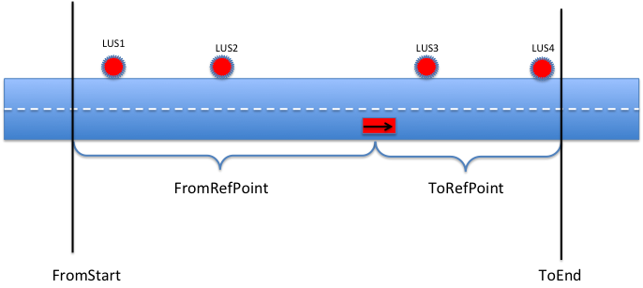

Fig 1

### Reference Point for roads within a tunnel

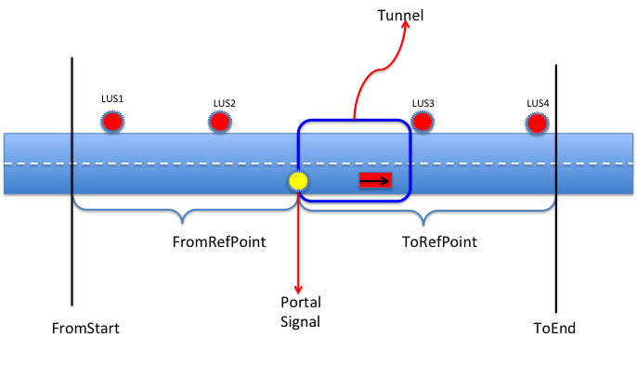

Fig 2

## Lane Usage Signal

The following settings are defined to configure Lane Usage Signal logic. A range [FromStart – ToEnd] is identified within that boundary all the LUS will be affected by the incident. A reference point is identified to measure the region boundary.

* Number of stages – Stages are defined as the time since incident has been detected. So this includes the time immediately after detecting the incident, incident duration & the time after the incident is cleared.

For each stage the following parameters will be set for LUS

1. Case ID – To identify the setting

This is the sum of

1. Lane blockage (partial = 1, complete = 2)
2. Emergency Vehicle Access (EVA) (16 = Upstream, 32 = downstream)
3. Signal State
   1. Red = 1
   2. Yellow = 2
   3. Green = 3
4. FromRefPoint is the location for FromStart defined as follows (*refer to Fig 1 & 2*):
   1. 1 = upstream portal signal
   2. 0 = incident
5. FromStart is the starting point which is measured by the distance upstream(+) or downstream (-) of FromRefPoint.
6. ToRefPoint is the reference location for ToEnd (definition same as (C))
7. ToEnd is the ending point which is measured by the distance upstream (+) or downstream (-) of ToRefPoint.

Example from MITSimLab Control Logic File

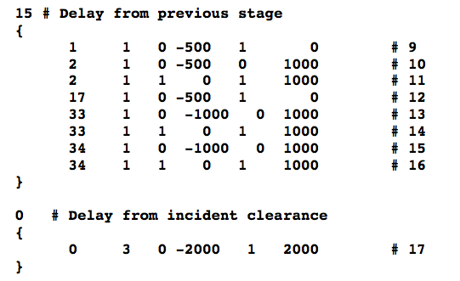

## Variable Speed Limit Sign (VSLS)

Here are the settings for setting the speed limit for the incident lane

* Number of stages – Stages are defined as the time since incident has been detected. So this includes the time immediately after detecting the incident, incident duration & the time after the incident is cleared.

For each stage the following parameters will be set for VSLS

1. Case ID – To identify the setting

This is the sum of

1. Lane blockage (partial = 1, complete = 2)
2. Emergency Vehicle Access (EVA) (16 = Upstream, 32 = downstream)
3. Speed limit increase/decrease by SpeedStep from SpeedStart upto the default speed limit of minimum speed limit defined in global parameter.
4. FromRefPoint is the location for FromStart defined as follows (*refer to Fig 1 & 2*):
   1. 1 = upstream portal signal
   2. 0 = incident
5. FromStart is the starting point which is measured by the distance upstream(+) or downstream (-) of FromRefPoint.
6. ToRefPoint is the reference location for ToEnd (definition same as (C))
7. ToEnd is the ending point which is measured by the distance upstream (+) or downstream (-) of ToRefPoint.

Example from MITSimLab Control Logic File

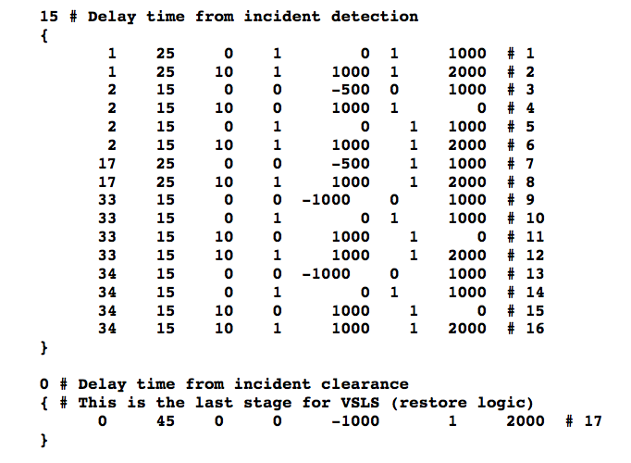

## Portal Closure

* Number of stages – Stages are defined as the time since incident has been detected. So this includes the time immediately after detecting the incident, incident duration & the time after the incident is cleared.

For each stage the following parameters will be set for VSLS

1. Case ID – To identify the setting

This is the sum of

1. Lane blockage (partial = 1, complete = 2)
2. Emergency Vehicle Access (EVA) (16 = Upstream, 32 = downstream)
3. State of portal signal

0 = Blank

1 = Red

2 = Yellow

3 = Green

8 = Flashing

Example from MITSimLab Control Logic File

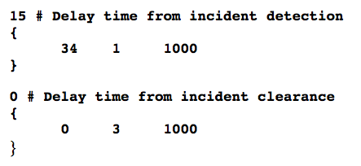

## Variable Message Sign

*Understanding VMS logic implementation from MITSimLab source code is in progress. Here we are listing the constant defined for VMS implementation.*

const UINT SIGN_ERROR = 0xFFFFFFFF;

const UINT SIGN_TYPE = 0xF0000000;

// The lowest 16 bits (the lowest 4 hex digits) is used to specify the

// subject the given message concerns (e.g. the id of a link, a vehicle

// type)

const UINT SIGN_PREFIX = 0xFFFF0000;

const UINT SIGN_SUFFIX = 0x0000FFFF;

#define SignPrefix(s) ((s) & 0xFFFF0000)

#define SignSuffix(s) ((s) & 0x0000FFFF)

// Actions: apply to the lane changes related both rule and path

const UINT SIGN_LANE_USE_LANES = 0x00F00000; // number of lanes

const UINT SIGN_LANE_USE_DIR = 0x03000000; // direction (sum)

const UINT SIGN_LANE_USE_DIR_R = 0x01000000; // right

const UINT SIGN_LANE_USE_DIR_L = 0x02000000; // left

// If this bit is set, the vehicles that DO NOT MEET the chooser

// condition apply the specified action.  If this bit is set, the

// vehicles MEET the chooser condition apply the action.

const UINT SIGN_NEGATIVE = 0x04000000; // reverse chooser

// If this bit is set, all vehicles meet the condition will comply

// regardless their compliance attribute

const UINT SIGN_MANDATORY = 0x08000000;

// Following sign constants should use only the highest 4 bits (the

// highest 1 hex digit) for sign type and the lowest 16 low bits (the

// lowest 4 hex digit) for information of choosing vehicles.

// Chooser: Lane use related to rules

const UINT SIGN_LANE_USE_RULE = 0x10000000;

const UINT SIGN_LANE_USE_CLASS = 0x0000000F; // vehicle class (sum)

const UINT SIGN_LANE_USE_GROUP = 0x0000FFF0; // vehicle group (sum)

// Chooser: Lane use related to paths

const UINT SIGN_LANE_USE_PATH = 0x20000000;

const UINT SIGN_LANE_USE_DEPTH = 0x000F0000; // max links to search

// Route guidance

const UINT SIGN_PATH = 0x30000000;

const UINT SIGN_PATH_DN_INDEX   = 0x0F000000; // which dn link

const UINT SIGN_PATH_COMPLY     = 0x00F00000; // compliance rate

const UINT SIGN_PATH_DEPTH = 0x000F0000; // max links to search

// Message for calling route switch model

const UINT SIGN_ENROUTE    = 0x40000000;

const UINT SIGN_ENROUTE_CLASS = 0x0F000000;

const UINT SIGN_ENROUTE_COMPLY = 0x00F00000;

const UINT SIGN_ENROUTE_TIMETAG = 0x000FFFFF;

# Appendix

Here is the component diagram of incident implementation in MITSimLab

Incident Signal

*(Virtual Signal)*

Traffic Signal

Variable Message Sign

Lane Use Sign

Variable speed limit sign

Portal Sign

Traffic Devices

TMS

Incident control logic and Response

Network State

Control & Route generation

Sensors

Driving Behaviour

* Car following
* Lane changing
* Acceleration
* Re-routing

Open Question:

1. Incident impact for the other modes?
2. How the actuated traffic control strategy will be impacted ?
3. Impact of different message text for VMS
4. Reaction Time of the driver

# Phase 1 implementation in simmobility

## Configurable Incident Parameters

Below are the list of parameter that can be configured in the config file

=======================================================

 incident definition

* + incident id,
  + visibilty distance(centrimetre),
  + segment id,
  + percentage position in segment,
  + severity code,
  + capacity factor,
  + start time,
  + duration,
  + speed limit in incident lane,
  + speed limit in adjacent lane,
  + lane id,
  + compliance weightage,
  + information accessibility

Current default value in the config file

  <incidentsData enabled="yes">

              <incident id="1" visibility="5000" segment="40200" position="50" severity="1" cap_factor="1.0" start_time="08:30:42" duration="00:40:00" speed_limit="0" speed_limit_adjacnetlanes="200" lane="0" compliance="50"     accessibility="50"/>

Below configurations are not used in the implementation yet

===============================================

cap_factor

compliance

accessibility

Parameter settings

==============

Incident Visibility Distance = 50 m (configurable)

Speed Limit in incident lane = 0 (configurable) --> complete stop

Speed Limit in the adjacent lanes = 7.2 km/h (configurable)

--> *this is almost 90% reduction of the default speed limit (70 km/h). This is not realistic value but modeler can configure it.*

Incident Duration = 40 min (start time & duration both are configurable parameter)

Implementation Details

==================

- In the below two cases the grey triangle indicates driver's search range within the simulator for the available obstacle. Value of this Range is set to 200m

- The red shape inside indicates the incident and the blue circle indicates the incident visibility distance which is set to 50 m.

- Now when the driver will search for all the incident in his search range then if he find there is an incident he will check the visibility distance of the incident. If the driver's position is not within this visibility range driver will ignore the incident.

- If the driver is within the visibility range of the incident which is shown in case 2 then the driver will consider MLC. Currently there is a probability distribution and in the video cars are shown in red if they fall in MLC regime

Case 1



Case 2



Video

=====

- Incident is appearing around 45 sec of the video

- the red circle indicates the incident visibility distance

- Cars with red color indicates they are within MLC regime

- Green/Yellow/Red arrows indicates the traffic light

Incident with first two lanes blocked

<https://dl.dropboxusercontent.com/u/66048809/SimMobility/INCIDENT_Demo/1st%20Video%281st%20two%20lanes%20blocked%29.mp4>

Incident with first lane blocked

<https://dl.dropboxusercontent.com/u/66048809/SimMobility/INCIDENT_Demo/2nd%20Video%281st%20lane%20blocked%29.mp4>

Incident with 2nd & 3rd lane blocked

<https://dl.dropboxusercontent.com/u/66048809/SimMobility/INCIDENT_Demo/3rd%20Video%282nd%20%26%203rd%20lane%20blocked%29.mp4>

Incident with some incident length

<https://dl.dropboxusercontent.com/u/66048809/SimMobility/INCIDENT_Demo/4th%20Video%20%28incident%20length%29.mp4>